**Delivery assignments Morocco, Meknès – Group 5**

Iris Sahin

Elisa Schmidt

Ramon Jongschaap

Daphne Kranenburg

Esmée Schadenberg

Gwenaël Le Pelvé

**Assignment 1 - the old Medina**

**Reflection upon the business process**

We visited the old Medina in a group of 6 the second day in Meknès. Walking around the square we saw a lot of shops and stands with local products and souvenirs fully displayed inside and outside to attract a lot of customers. Here we came in contact with a new method of acquiring and selling goods and food. We think negotiating is an interesting way of doing business, since we don’t see this that often in the Netherlands. What we also find interesting, is that there were no price tags on any products in the shops of the old Medina. All the prices are made up for the individual customer, especially for tourists the numbers are always higher. Bargaining is not always that easy as you can see in the video, you really have to “push” to try to convince the seller to lower the price, sometimes you just need luck to get a good one. However, most of the customers at these shops in the Medina were locals. It was easy to tell, because they knew exactly how everything worked, they exactly knew how to negotiate the prices with the sellers. On the other hand, for us it was much harder and a longer process.

We have visited some shops, but some were closed. We did not eat traditional food at the Medina, but we drunk some Moroccan tea at a roof-terrace where we had a nice view of the old Medina.

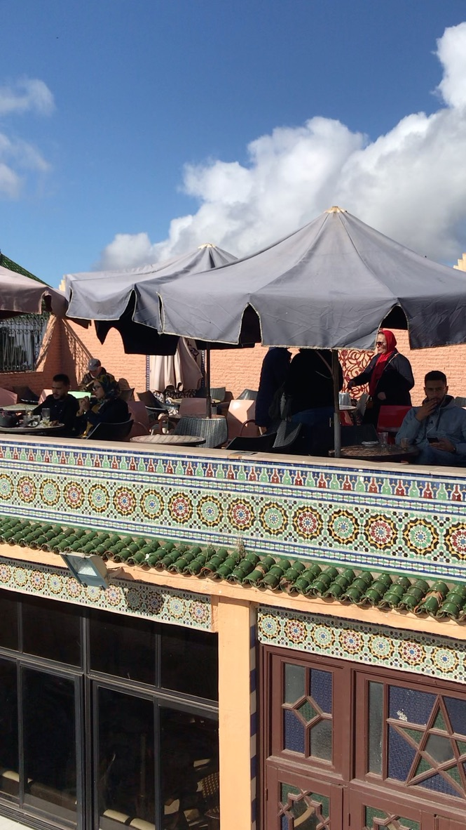

This video was made at a roof-terrace of a place at the Medina. We got a really nice view of the Old-Medina here.

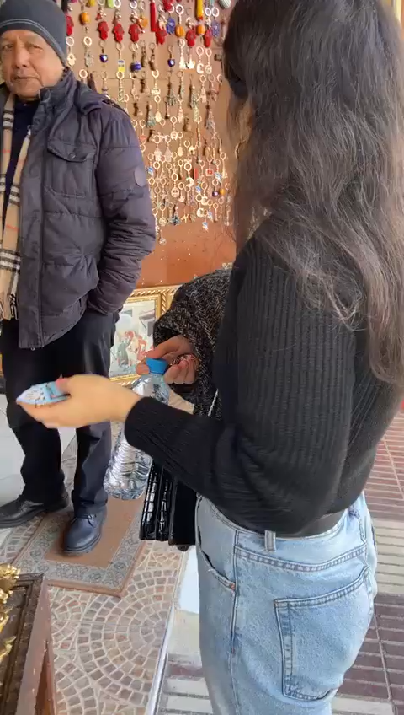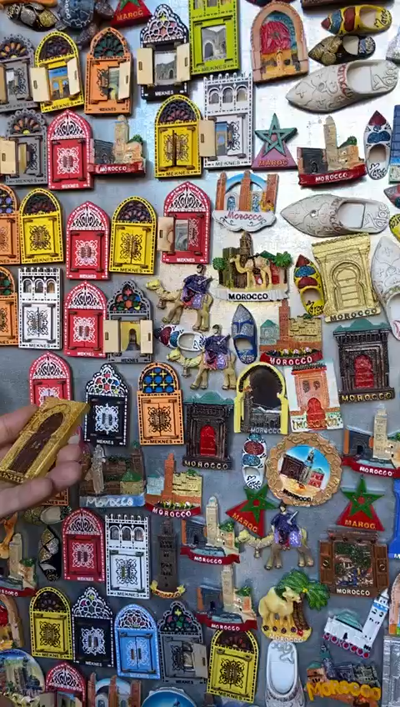**Negotiating videos in Medina**

**Group pictures at the Old-Medina**

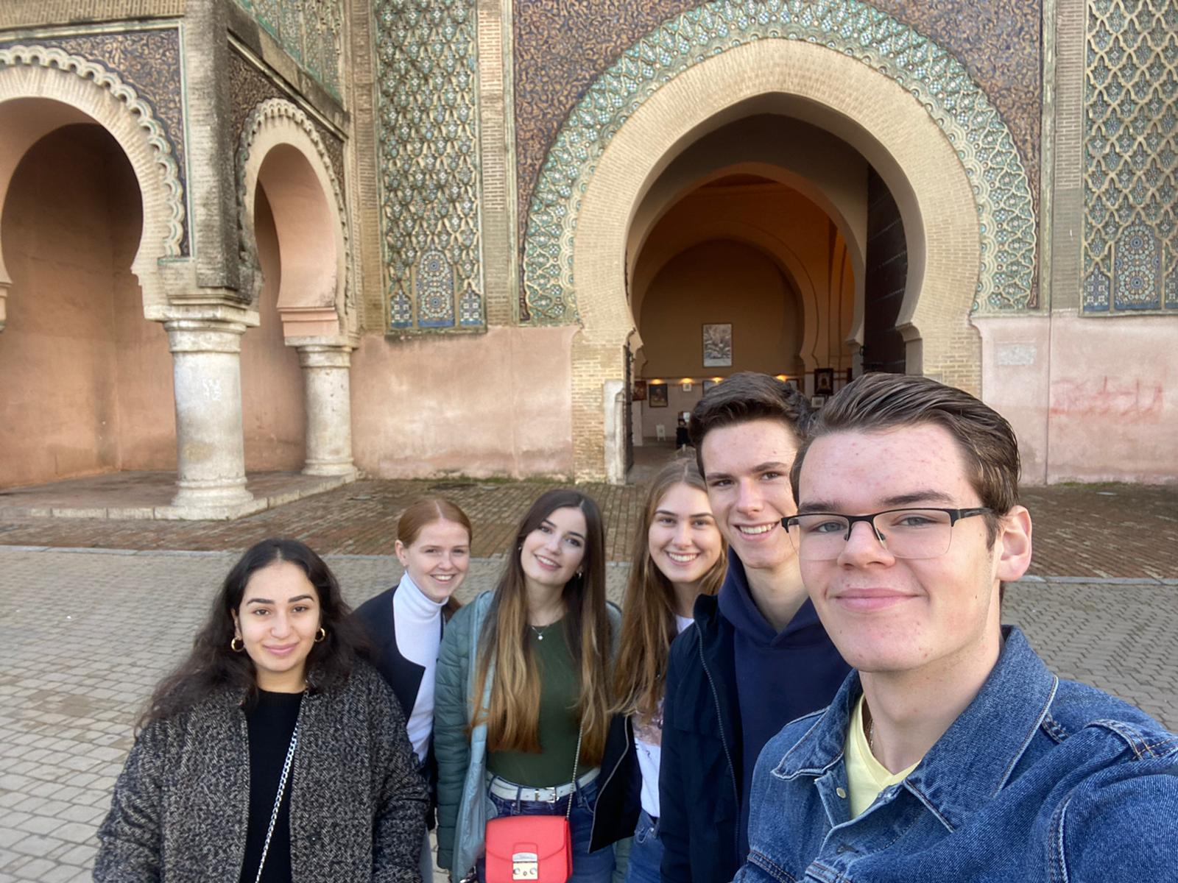

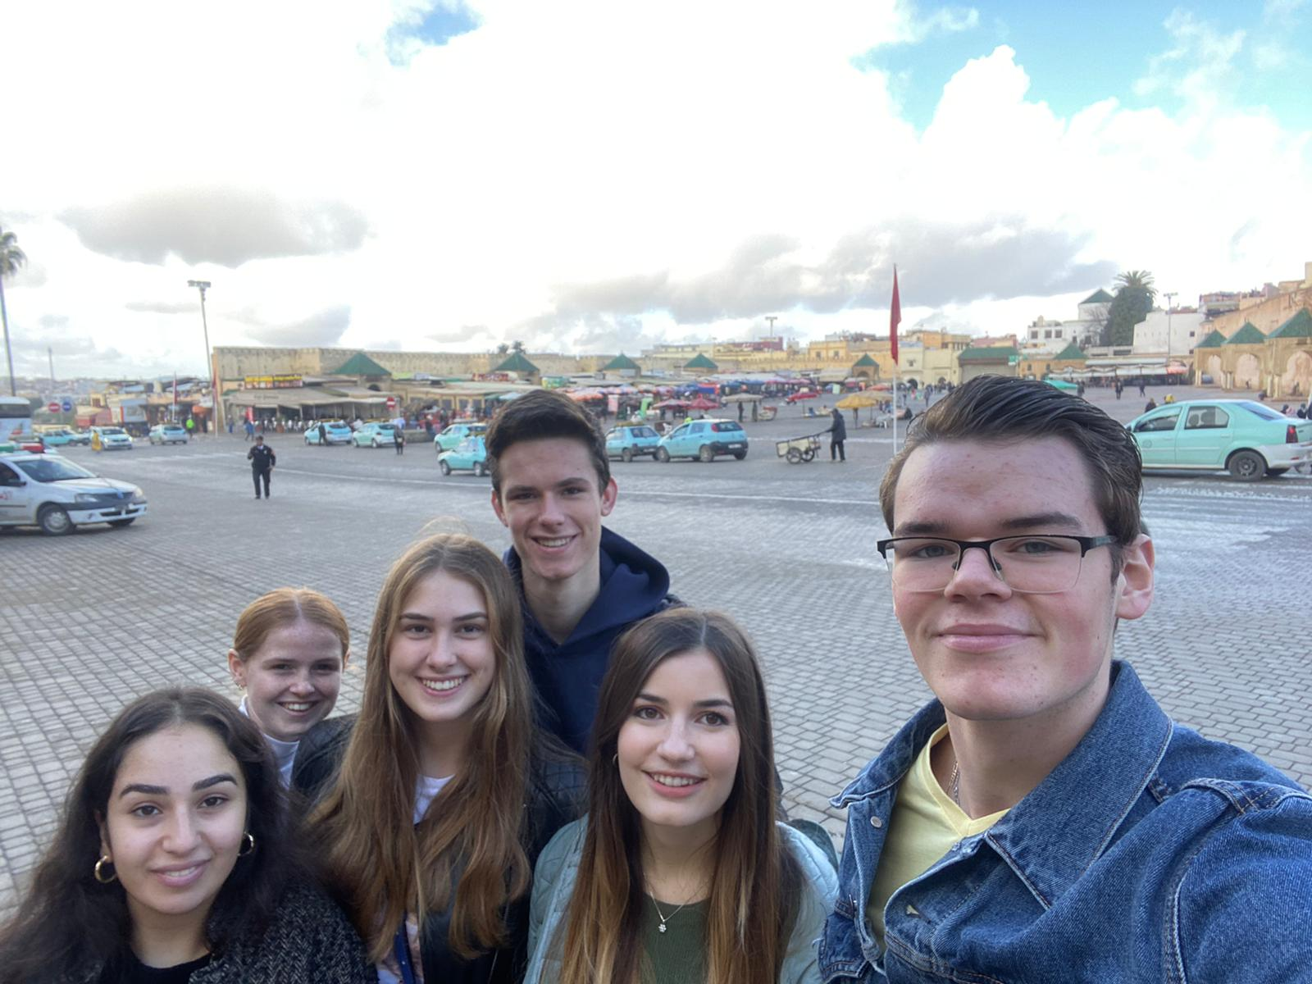

**Assignment 2 – Mausoleum Moulay Ismail**

We could not do the second assignment because we were not allowed to go in since we are all non-Muslims. Non-Muslims are not allowed to visit the Mosque. The Mosque was also under construction, so we could not visit it at all.

On Sunday we had most of the morning and afternoon for ourselves. During this time it was ideal to make the assignments with the group. In the beginning we walked with the whole group ( 25+- students) to the old medina. When we came there we made some pictures and asked for the way to the old mosque for the assignment. When we found the mosque we walked around it and asked a man if we could enter but we couldn’t. later on when we finished the assignments we went to the old man his shop and bought a lot of stuff there for our friends and family back home. The man explained us something about the Mosque, but to honest, we could not understand really well what he said. He invited us to visit his store so he could explain the specialty of Meknes (see video). The man was doing business very well and het got a lot customers probably that day.

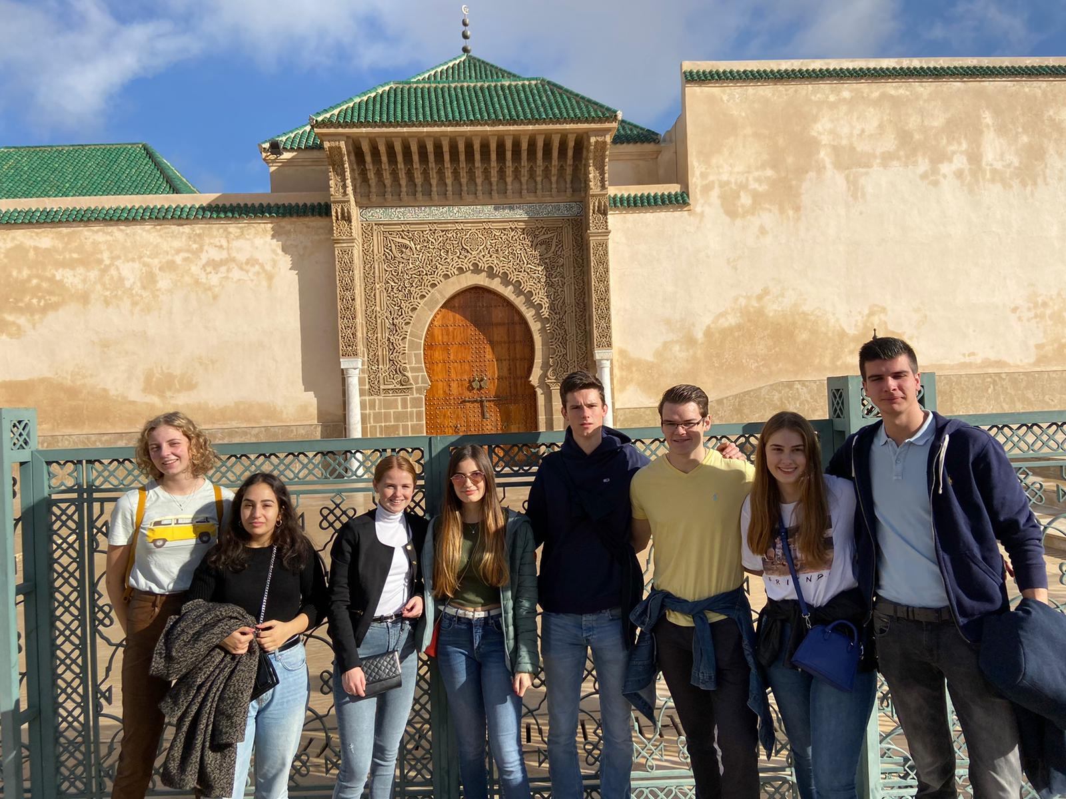

Group picture of our group and some other students in front of the Mosque.

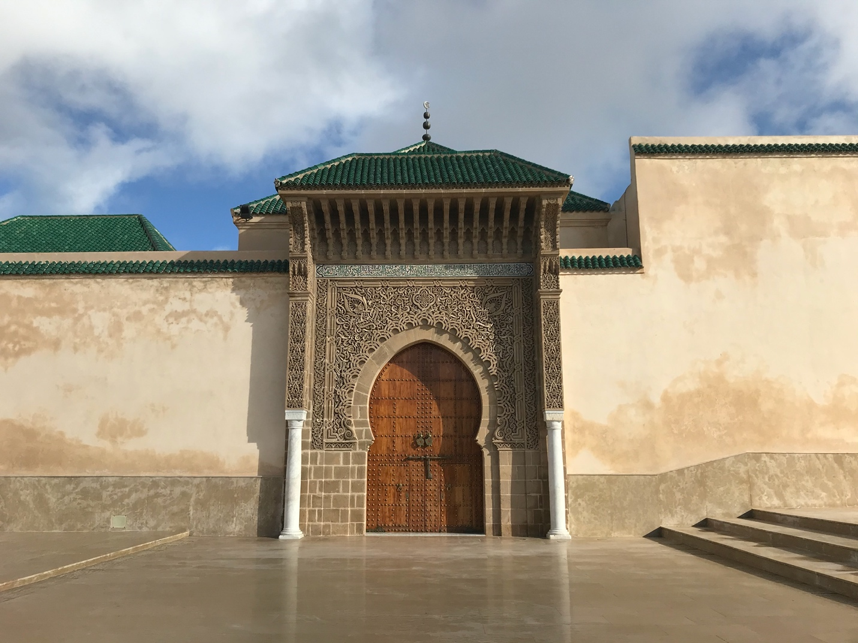

The man told us that the Allah script was the green are above the door. We could not read it inside the Mosque because we could not go in.

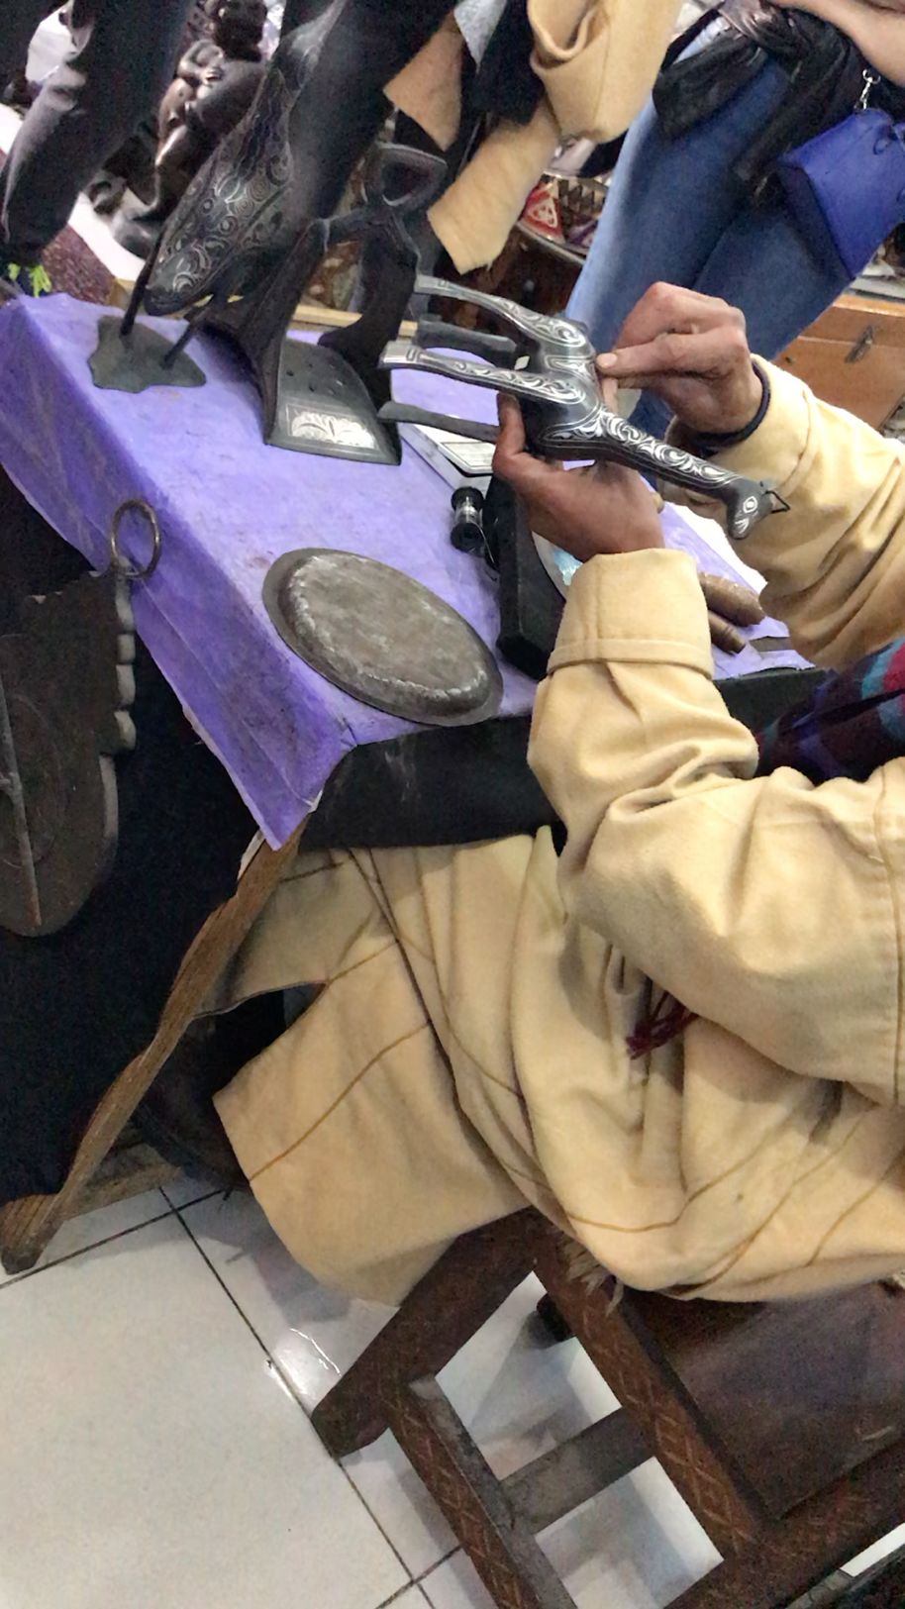Here the shop-owner, who gave us some information about the Mosque explained us how they make the Meknes specialty. It was interesting to see and he got almost all of us interested and many of us bought something at his shop. The business process at this shop was of course that the man got us all into the store by first helping is out by telling a story, then he explained something and he told us several times ‘student price’ and ‘very cheap’. We tried to negotiate, but they were also trying hard.

**Assignment 3 – La belle Vie or Supermarket Marjan**

We separated our group in two groups of three and we both took a gap to La Belle Vie. There was no need to negotiate about the price of the taxi meter because they use a meter, what we think is more reliable. The taxi ride was really fun and the traffic was chaotic. The price of the taxis are really cheap, especially when we compare these prices with the Dutch prices of a taxi ride. We paid less than one euro for the taxi ride.

If you take a taxi with three people everything is fine. We also went by taxi sometime with six people while the car was only made for three people. We have seen that this happens a lot in Meknes. The cars are filled with people. We did not have space and it is not comfortable at all. With three people in a taxi is fine, the drivers are nice, they drive fast and as we said before it is cheap.

****The assignment we had to do in the La Belle Vie was dancing with strangers. We first wanted to do this in the supermarket but the people did not look like they were in the mood for a dance and it was a real super market. We went outside and checked if there were some people who could dance with us. We choose to dance with a security guard of the supermarket, we asked him to do some Moroccan moves so we could imitate him. It was really funny to dance outside of the supermarket with him and he liked dancing with us as well. He wanted us to hear all kind of Moroccan songs. We communicated with him in French, he understood it quite well but some words he just did not know, so we used Google Translate to translate some words he did not understand to Arabic.

See here the video where we try to do our best Moroccan dance moves. Unfortunately you can not hear the song very well, but we could : )

**The business process in the malls and contrast with the Old-Medina business process**

We first went to the old medina. There the shops were usually small and there were as many products in there as possible. Most of the products there were handmade (they said). A lot of products had no price on it, and when you ask them what the price is they often said I have a student price for you. The prices were at the beginning all the time really high, but you could easily negotiate with them. What also was remarkable was that some people were really trying to get you to buy something at their place. They were saying come here, come look at this, you need to see this, I have something special for you. Sometimes it was a bit annoying, but for the most time it was fine.

Then we went to the mall. It was really different compared with the medina. It was a clean big mall, the security guard told us to have a nice day. The stores were big and clean, they looked like stores we have in the Netherlands. Nobody was pushing to buy us anything, they just let us walk in their stores without telling us anything. There were also some expensive items there and nothing was handmade by them. Negotiating there was no use, they had fixed prices on the products so they would not give us a different price because we were travelers and the locals paid the same price as we did.

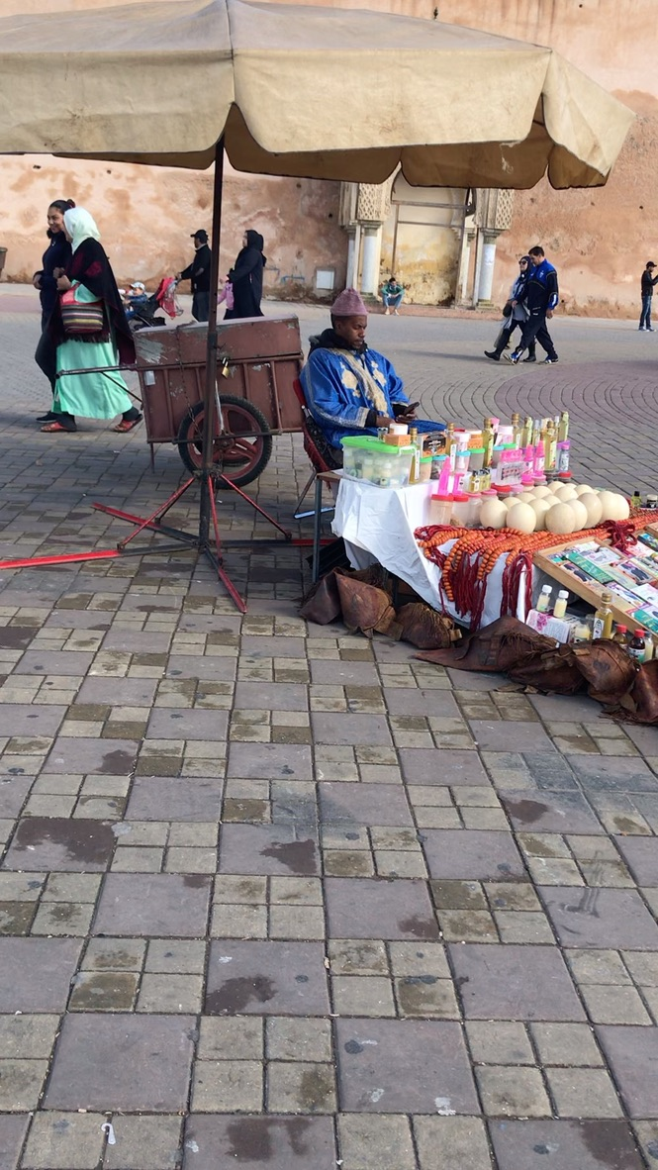

This video was made at the Old-Medina. There randomly was an Ostrich at the square.

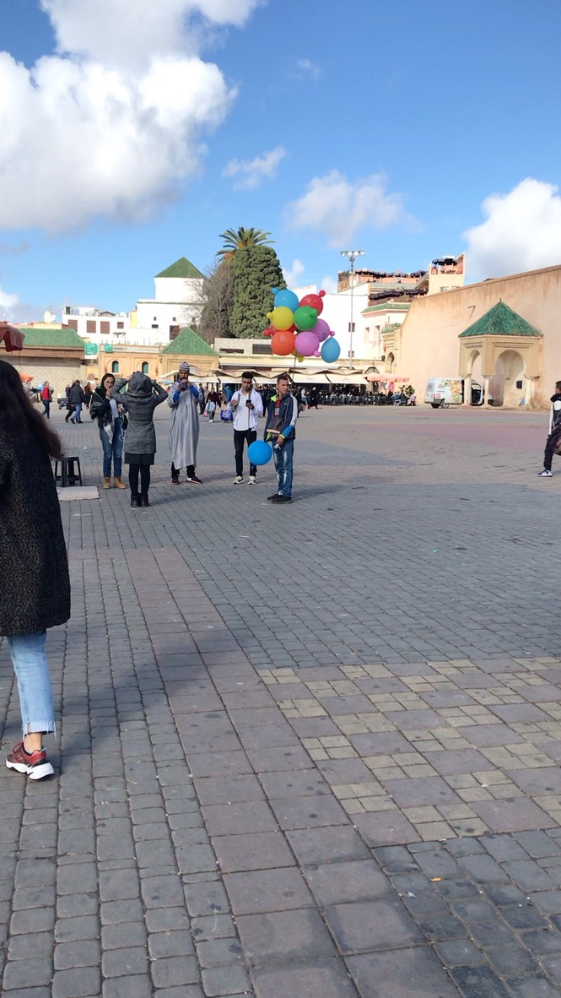

They asked us many times if we wanted to make pictures with snakes and they came to us with the snakes.

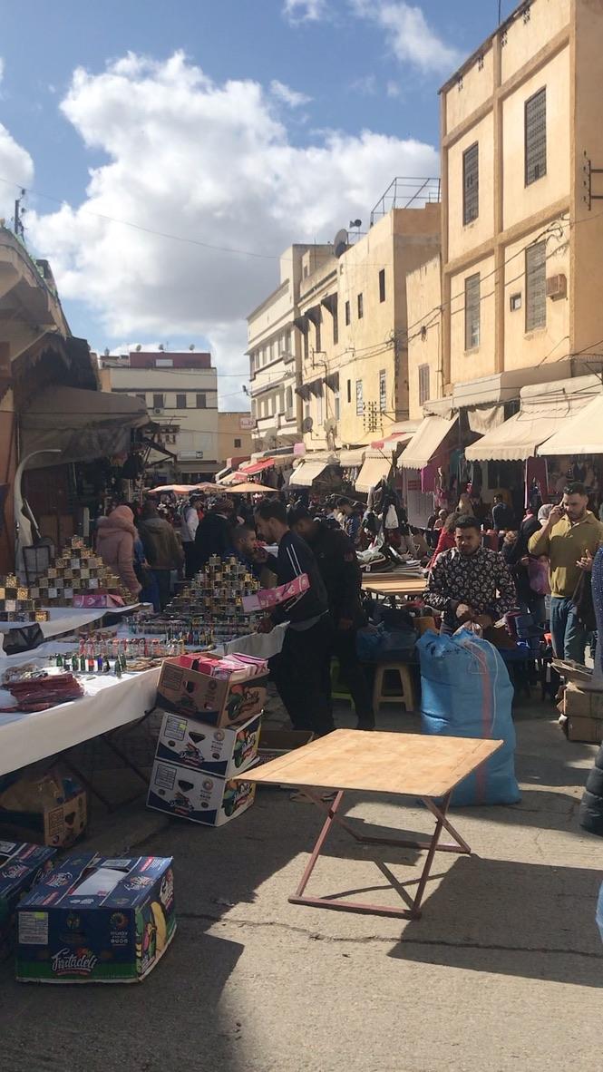

The markets in the Old-Medina were really busy. People screamed to us and to the locals and were really trying to sell their stuff.

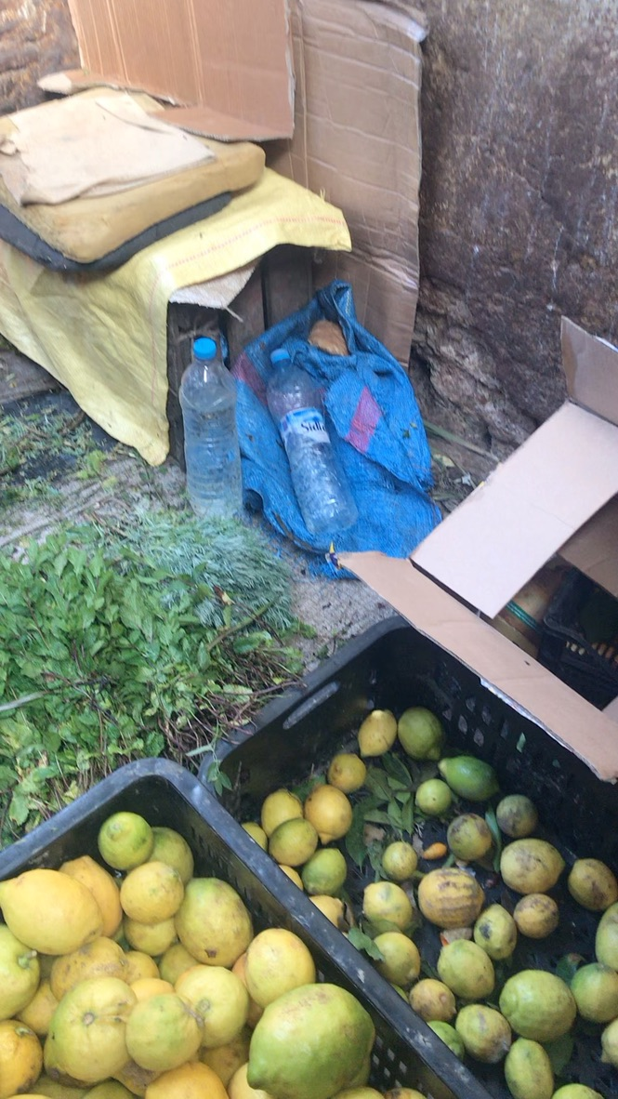

It was really interesting to see the business processes at the markets. Here we saw some similarities with the Netherlands, because people in the Netherlands scream their prices as well.

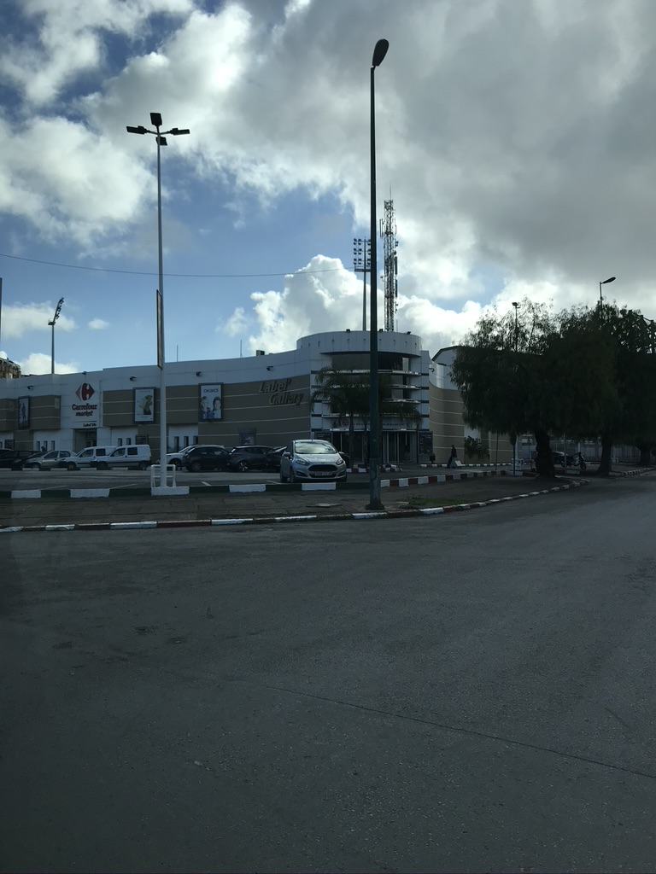

A picture made of the outside of the Labelle Vie and the Carrefour where we looked for different and similar products as we have in the Netherlands.

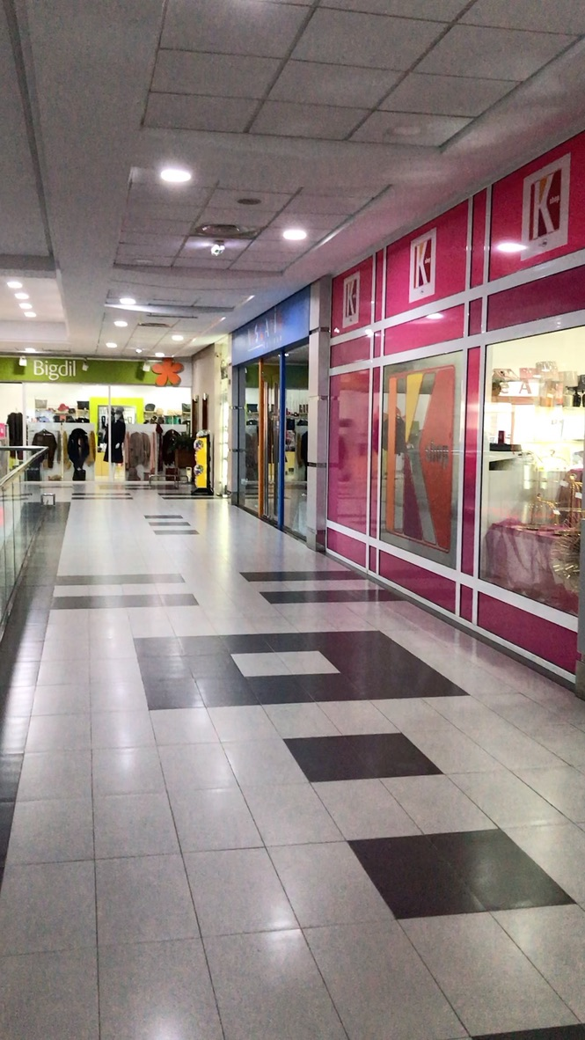

This video gives a good insight about how the shops are at La Belle Vie. The shops are way much formal, the prices are fixed and no one pushes you to buy something. The people who come her are probably living a better wealth.

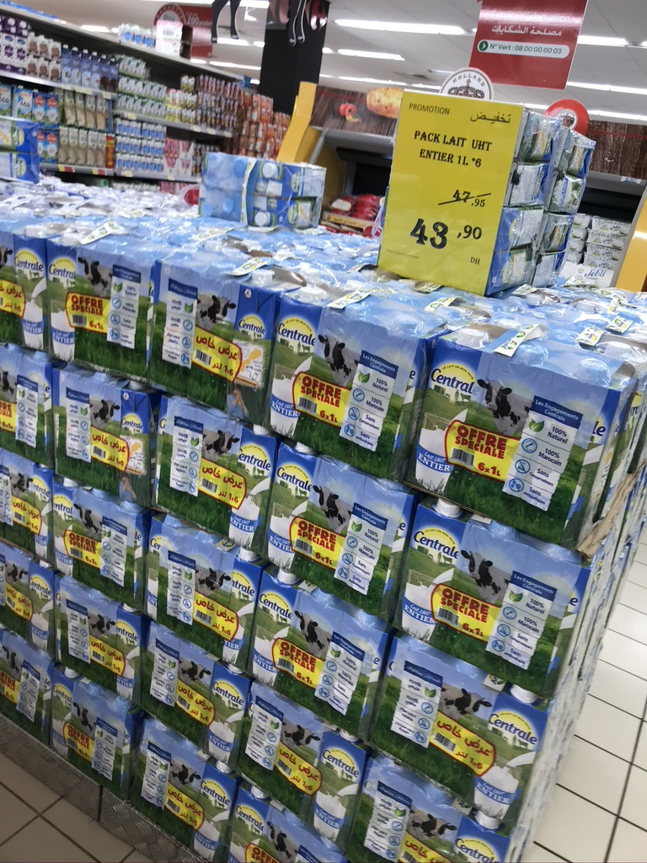

This photo shows that the products in the supermarket have fixed prices and that they have special offers as well. This works the same in The Netherlands.

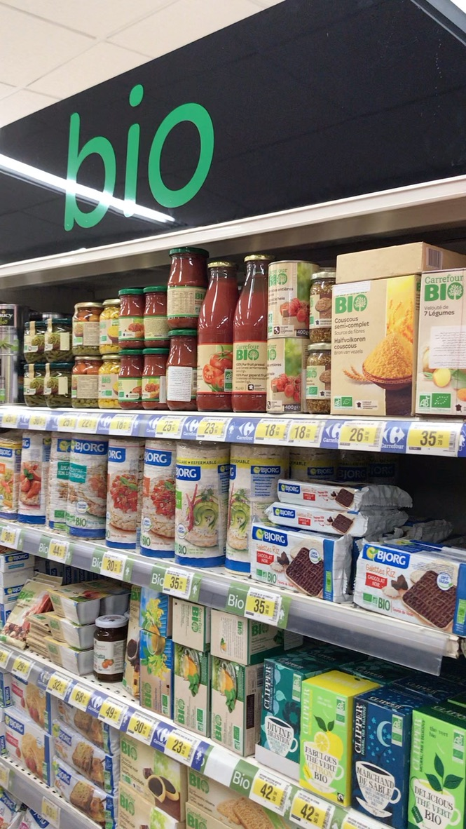

The supermarkets even had a **bio** department with all kind of biological food products.

In the supermarket we found some similarities with products we have in our supermarkets in the Netherlands as well. For example, the milk, a typical Dutch product. The products have fixed prices in the supermarket and just like the Netherlands they have special offers in the supermarkets as well to make it attractive for their customers. We even found bacon made of pig meat in the stores. We did not expect to see this in the Moroccan supermarkets because of the culture. The product even had a Dutch description on it, where we were even more surprised about.

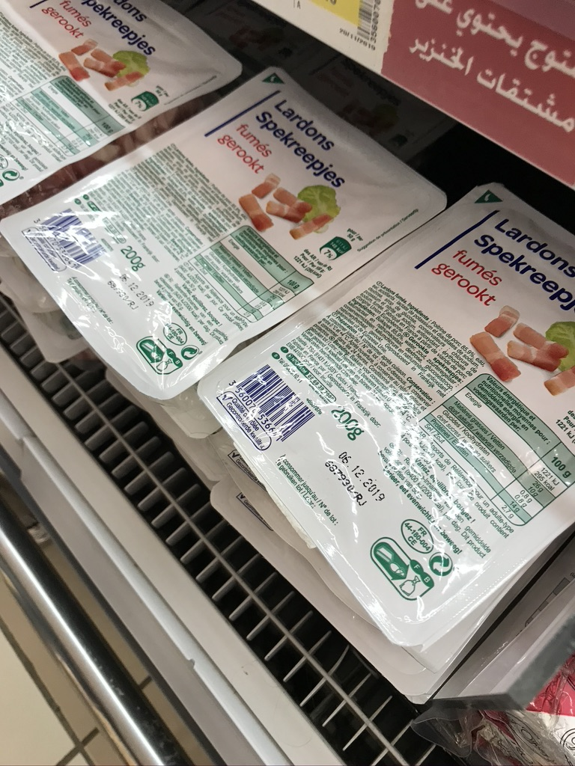

The bio products are not necessarily from the Netherlands, but this is something we have in the Netherlands a lot as well. Also this is something we did not really expect to see in the supermarkets, but people here could of course also be vegetarian.

At the cookies department we saw Prince cookies. These cookies we also see a lot in the Dutch supermarkets and I think that everyone in the Netherlands know about them. The prices of the products are quite similar to our products, maybe they are even a bit more expensive, but they have a lot ‘B’ brands which are sold for cheaper prices.

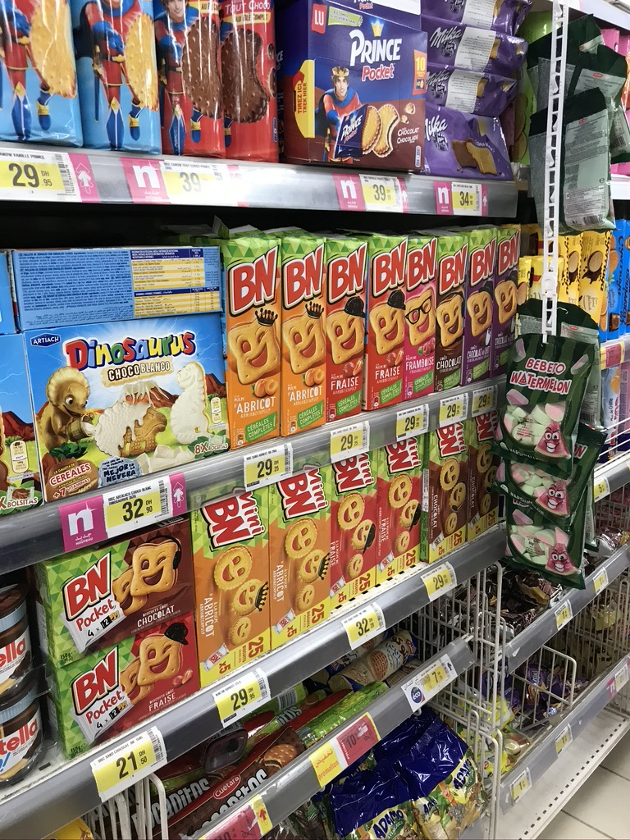

Also Nutella is a big thing in the Moroccan supermarkets. We have seen this is a lot in the supermarkets and at the small markets in the Old-Medina.

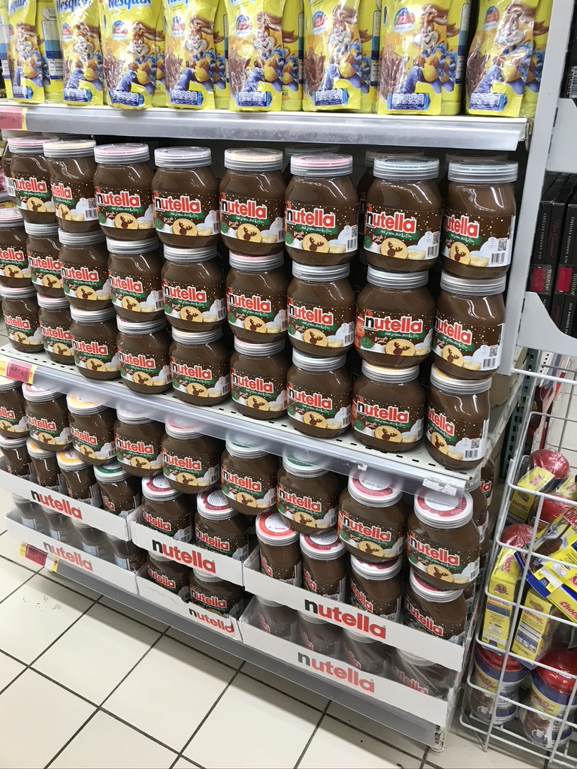

Another similar product to the products we have in the Netherlands are the products from the brand Nivea. Nivea is not a Dutch product (it’s German), but it’s a western product.

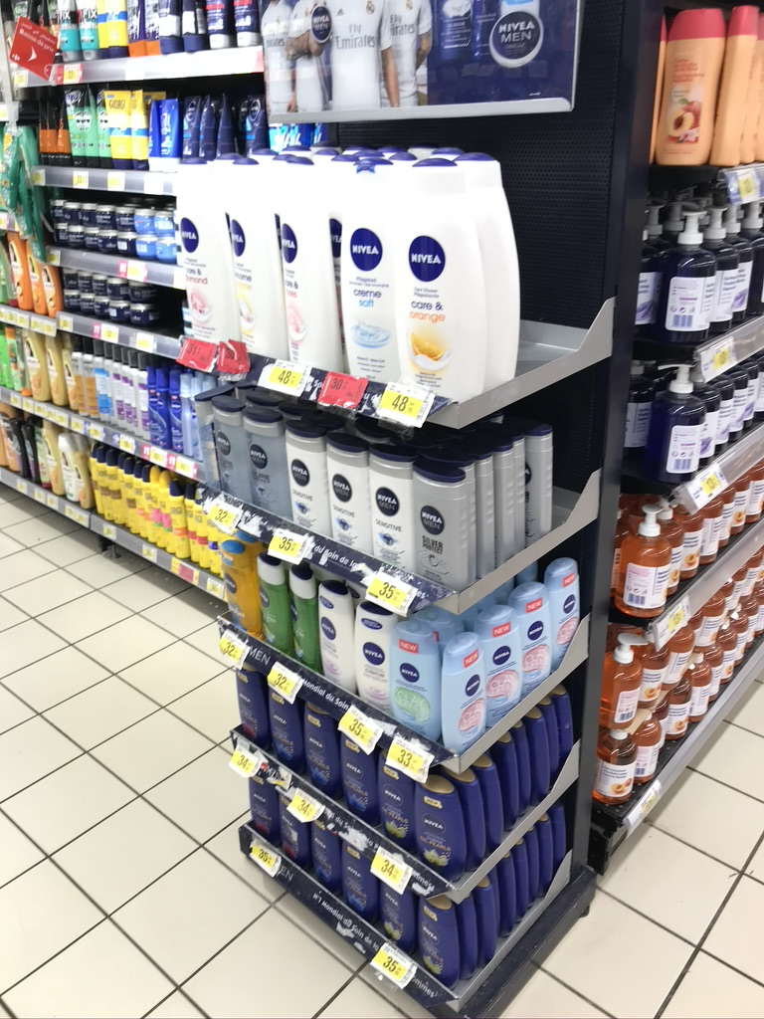

So, overall there are a lot of similar products in the Carrefour, the Moroccan supermarket. Milk is for sure a Dutch product, but beside that and the bacon we have not seen other real Dutch products. Maybe the cauliflowers.

Some products that would be nice for in the supermarkets in the Netherlands will be these showed on the pictures below. They give you the possibility to take as much pasta, rice or other things on the pictures as you need. They also sell all kind of different olives. We have these products of course as well in the Netherlands, but the way they sell it is quite different than how it is sold in the Netherlands. Overall we have seen more similarities in the Carrefour than differences. A lot of products are the same, or look the same as we have them in the Dutch supermarkets and we have even found products like milk, cauliflowers.

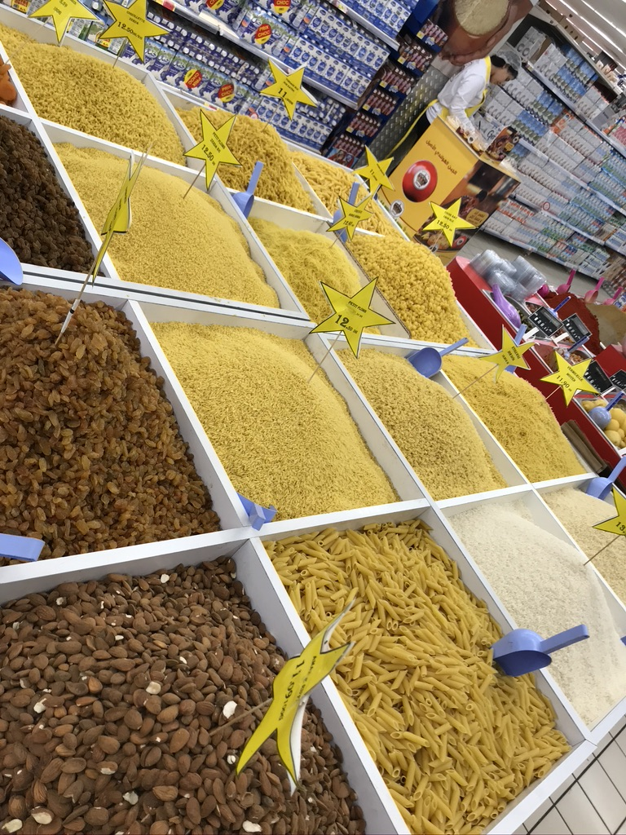

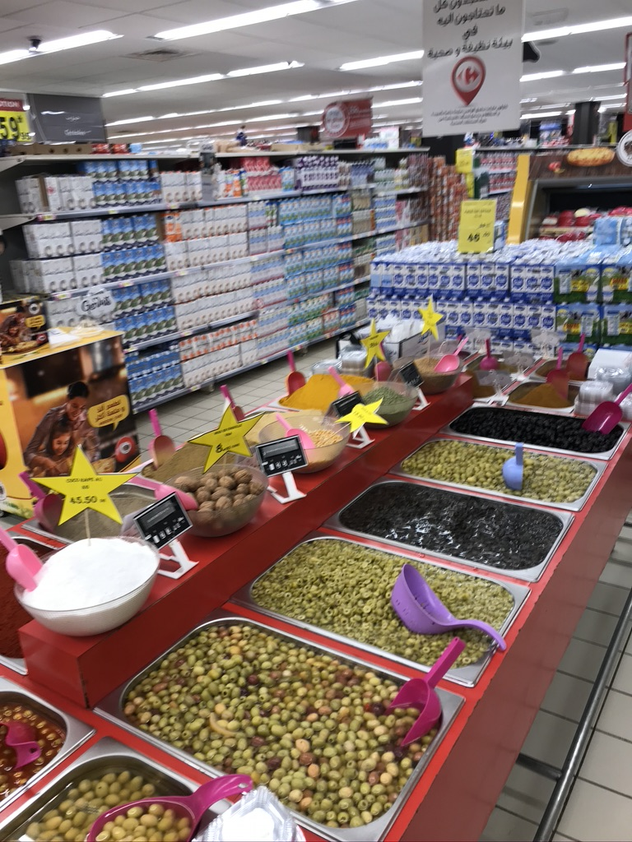

Here are some photos of the best food moments we experienced during our trip

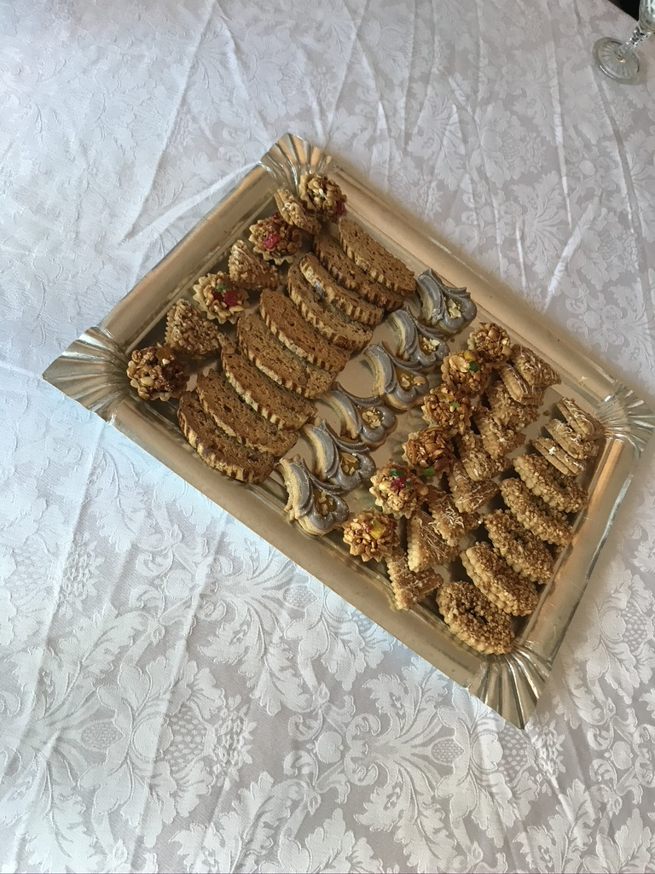

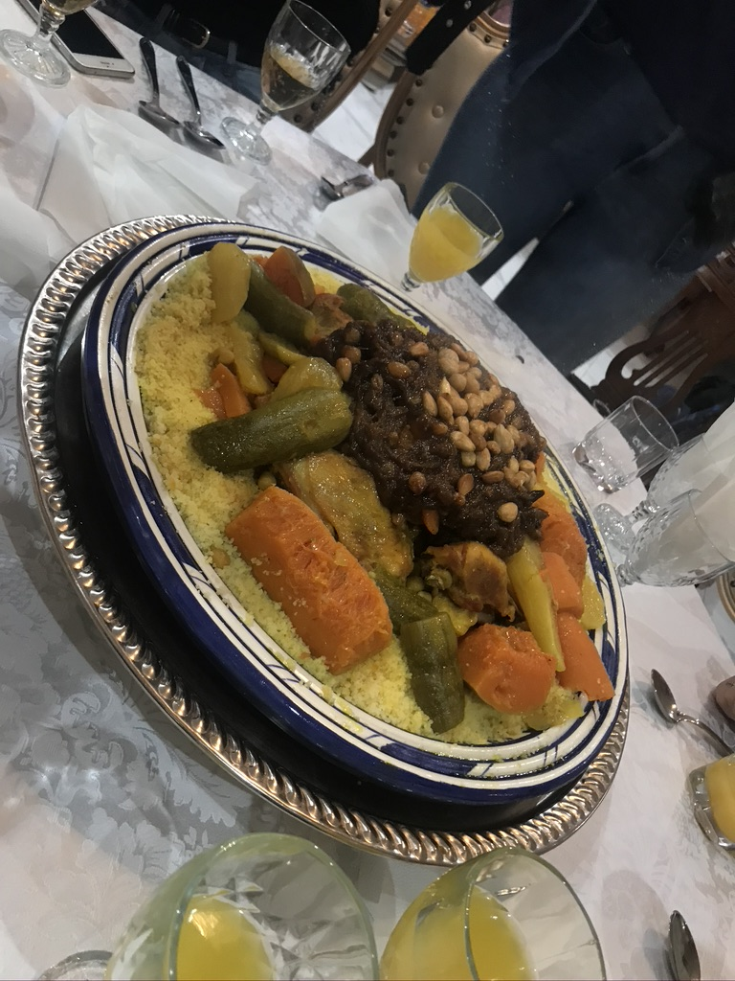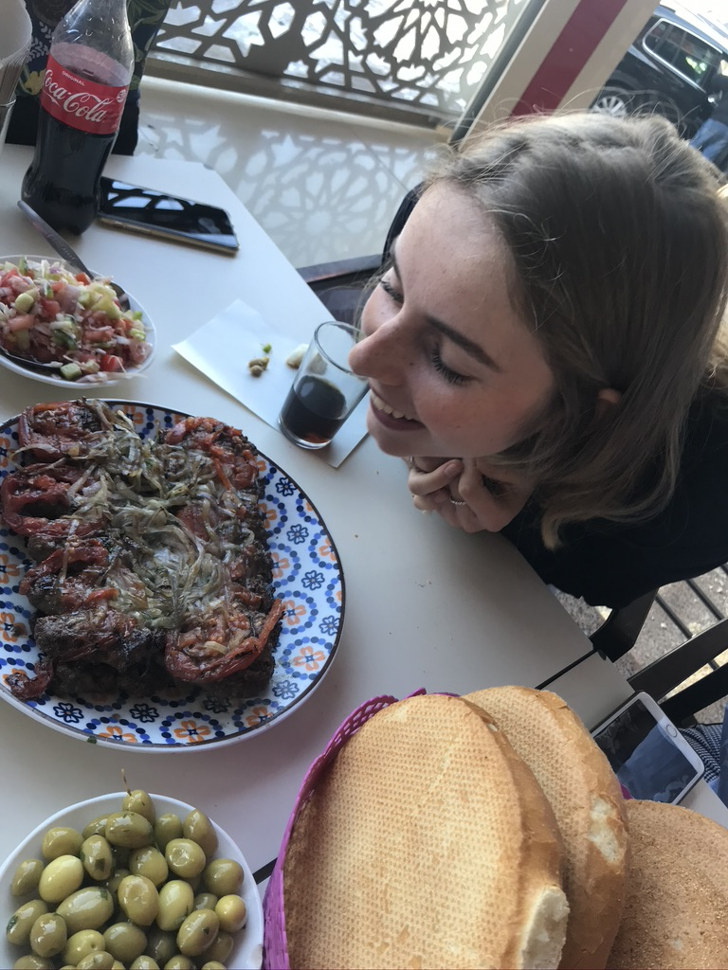

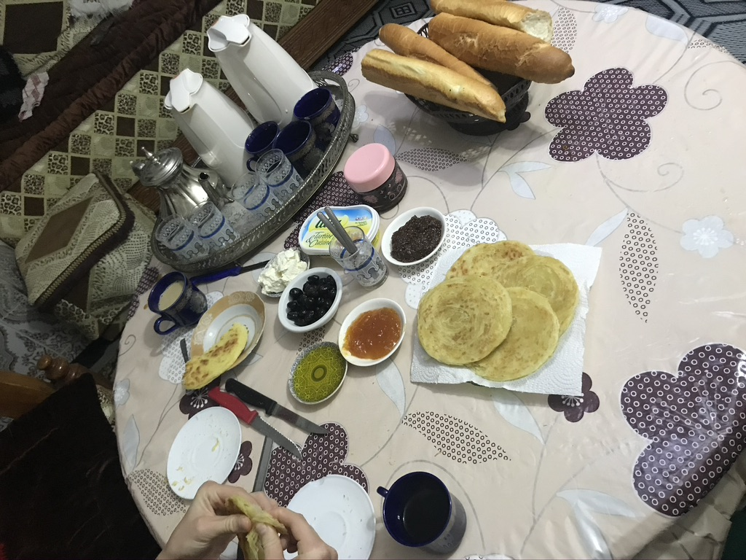

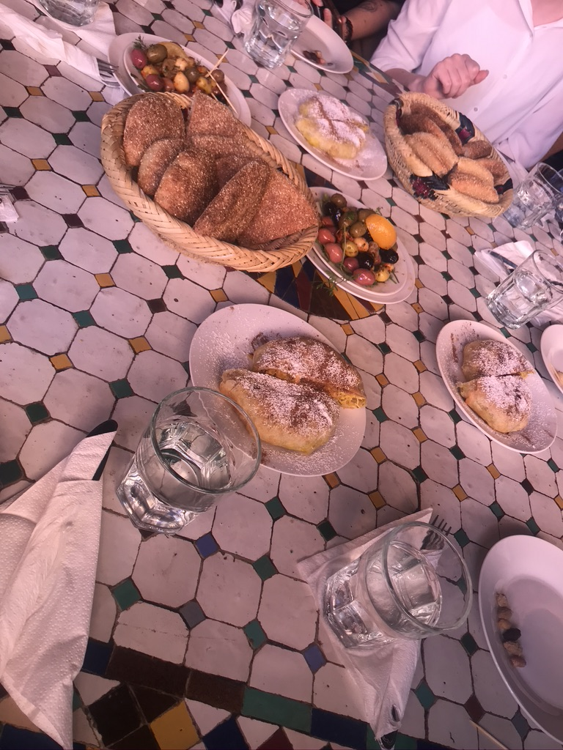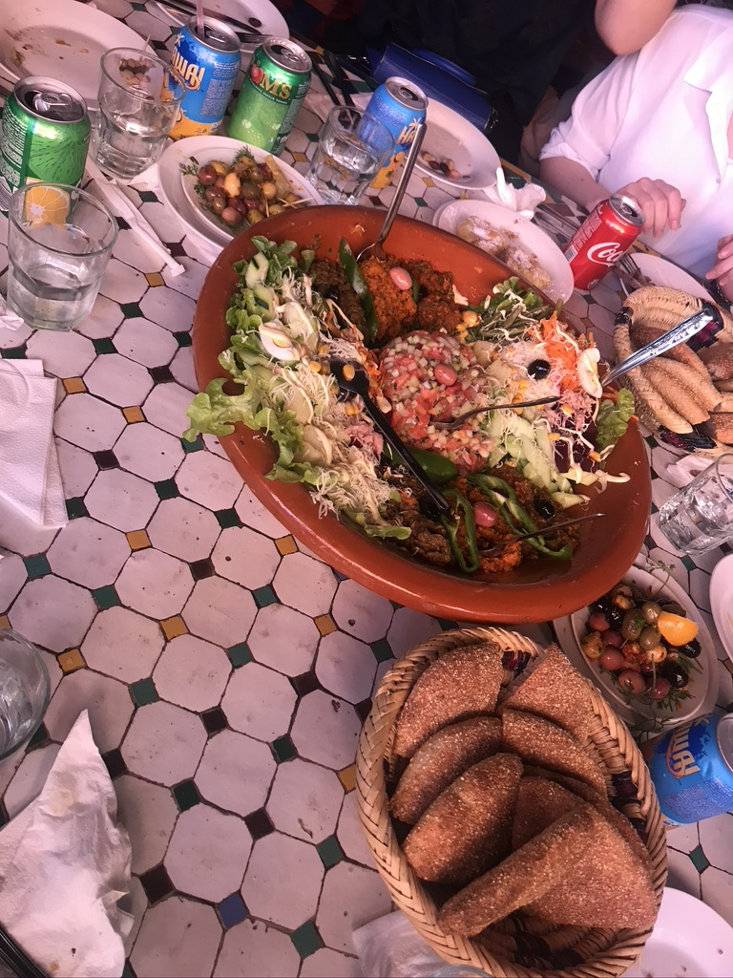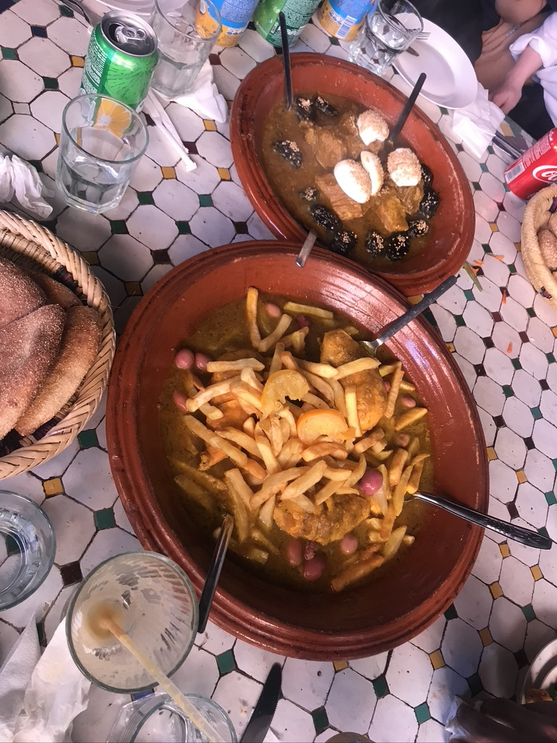

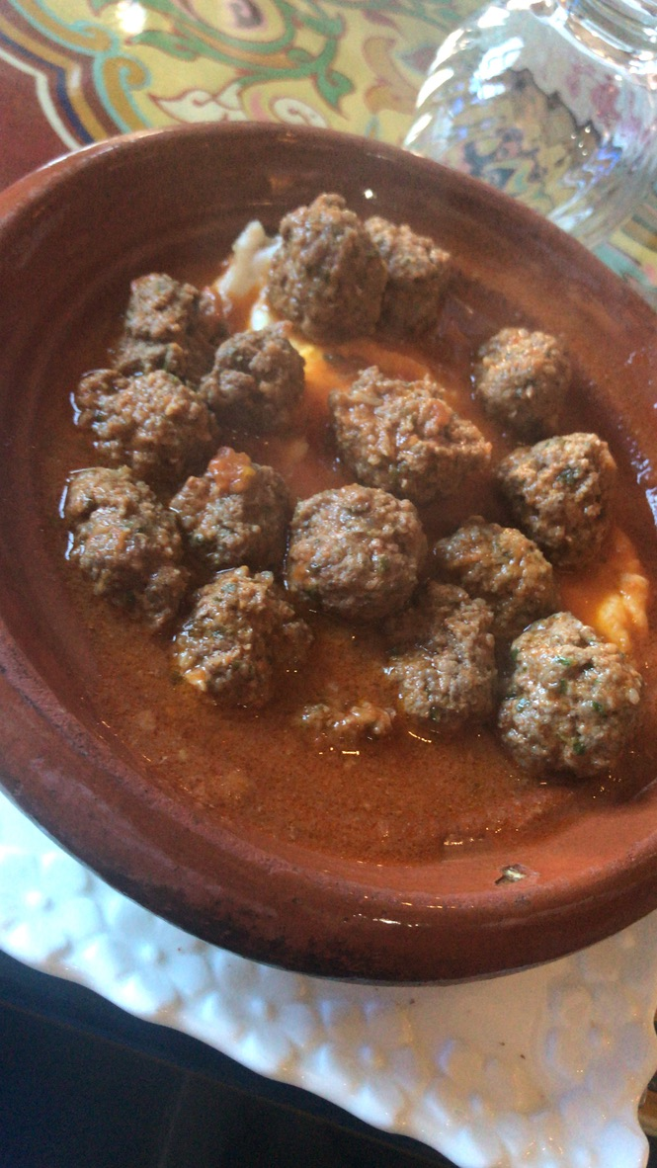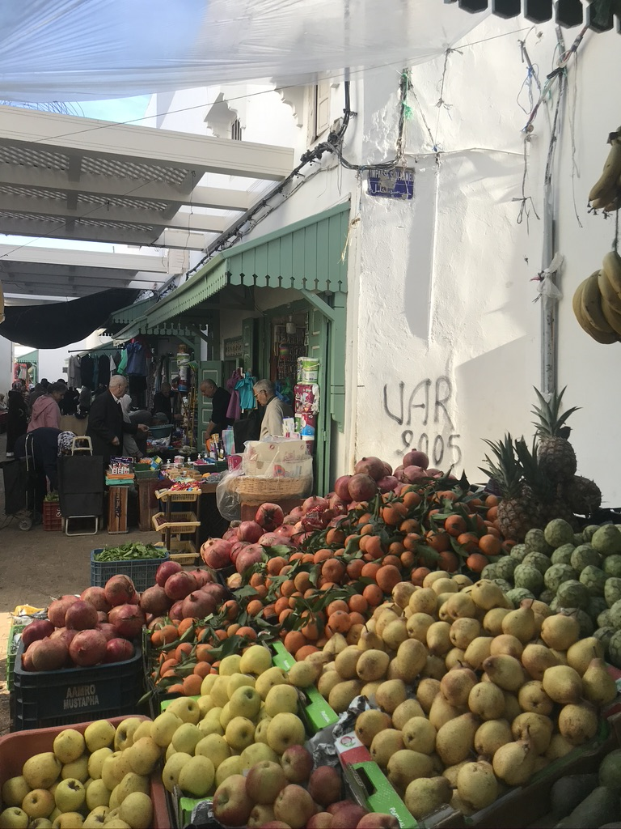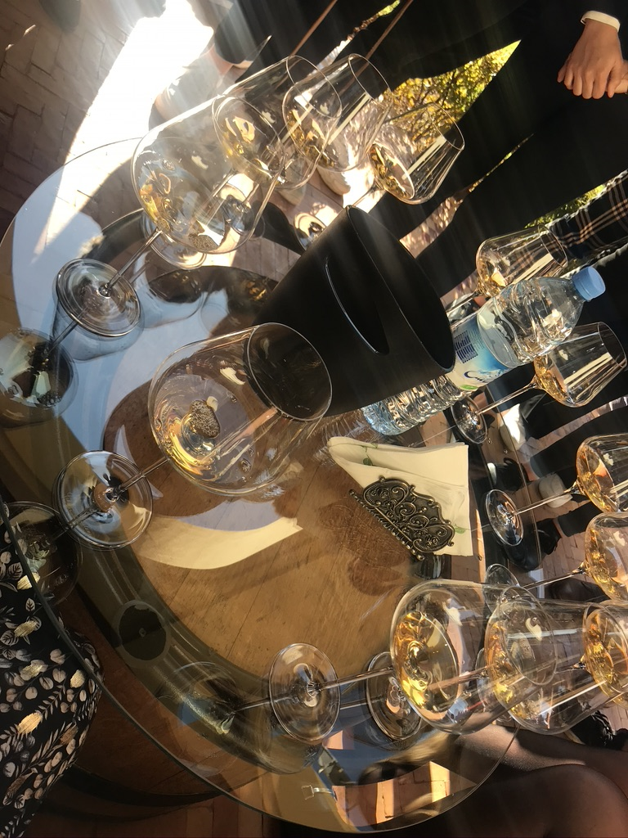

**Description of the ISA**

When we had the kick off of the ISA festival and they told us about the destinations we could go, I was already sure that I wanted to go to Morocco. I actually liked all the destinations but Morocco would not be my first choice travel destination if I travel by myself and that is why I wanted to it experience it now, with a group of students. The number of participants will be around 30 students, a lot of students I do not know yet but this is what I also like about the international student activities. As far as I know our program does not consist activities with other schools, which I think is pity, but we are going a lot of other nice things, so I am fine with it. Next year I think I will choose an ISA where other Universities are involved to the program because I think it is really interesting to learn from students in other countries and learn about the differences between us and them. I think our program will be really nice. I did some research to the companies we will visit and it seems all really interesting. The other thing I am really looking forward to is our stay at the host family. In my opinion the best way to learn about a culture is to live the culture and that is what we will do. The first thing I have already learned from Gerben about Morocco is that meetings and other appointments will be verified or cancelled really last minute. Despite that I do not know that much about Morocco yet, but I am really curious about everything, like the culture, the food, the business life, how people live, what they do etc.

**Why did I choose to go to Morocco and what are my expectations?**

So, I the main reason why I chose this ISA is because I would not go there myself really soon, but I know it is a country I would love to see. I have a big passion for travelling but I have never been in Africa and despite Turkey I have never been to an Islamic country before. I think Morocco is a very interesting country and there is a lot to learn for me. Beside that I would not go really soon myself I am really curious about how they are doing business in Morocco and to the Islam and Muslim culture in Morocco. I always wanted to go to Marrakech because of all the beautiful pictures I have seen on Instagram of it. Even though I would really liked it if we’d went there, I think I am happy that during this trip we are not going there. I can always go to Marrakech myself, but I would not come up with going to Fes or Meknes when I am planning a trip myself.

My expectations are that it will be a really nice week and that I will meet a lot of new people who share the same interests as I do. I also expect that Morocco is a nice country, that the people will be really kind and that we will learn a lot about the business processes in Morocco. I am really looking forward to our stay at the host family and I expect that I will learn about the Moroccan culture during our stay at the host family. Beside these expectations I do not have that many expectations about Morocco, I think it will be really nice and I will see what happen, what I learn and how the Moroccan life is. I am really looking forward to learn about a new culture and see what Morocco has to offer.

**My learning goals**

**Professional Practice Learning outcomes**

* **Ability to work in a multicultural team:** Understand diverse set of behaviours, attitudes, and practical skills **and** Ethical responsibility within the professional context

**Cultural immersion Learning outcomes**

* Ability to analyse and interpret behaviour of self and others
* Effective communication skills

I chose ‘ability to work in a multicultural team’ because I think it is very important to work with people and students with different nationalities. It is also a very important thing during my study since and for my career when I am graduated. This is where international business is about: working in multicultural teams. I think it is important to learn about as many nationalities as possible and know how they work within teams and how they are doing business.

I want to learn about the behaviour of the people in Morocco I will meet and see. I think this is also very interesting: see and learn about the cultural differences between my culture and the Moroccan culture.

I know that there probably will be a language barrier, but I do not see this as an obstacle, I am sure that however there is a way to communicate with people. I know some French words I learned at high school, but not all the people speak French. I see this as a challenge, an interesting challenge.

**The relation of this ISA with the IB core program learning outcomes**

This ISA will help me with developing my skills related to some learning outcomes of the IB program. At first, I think this ISA will help me with my personal development. It will help me with recognising my skills and to see things I still could improve. Travelling is always good to develop yourself and we are going to see business in another environment. I will get more aware of how business is in Morocco and what the differences and similarities are compared to the Netherlands. International business awareness is one of the learning outcomes of the IB program. The ISA supports this learning outcome by giving us the chance to go abroad and learn about business related things. This is a thing I really like about this program and NHL Stenden. It gives you many chances to improve yourself and develop yourself in all kind of ways. I will learn about the international business environment in Morocco and how people interact and negotiate with the local people and us, the ‘tourists’. This is something I am curious about. When I was in Turkey I already explored how they are doing business with tourist and I think that Turkey and Morocco will have some similarities, but I will see if my gut feeling is right. The other thing this ISA will bring is learning how to work in multicultural teams. Despite we are not going to work with fellow students from other universities, we still are in a group with a lot of different nationalities. We have to do assignments and we have to spend a whole week together, which could also be a challenge. I like working with different nationalities and see how different nationalities work different. Working in multicultural groups is also something I will probably encounter many times during my career. My ambition is to work at an international company, I even prefer working outside Europe, so I will probably encounter some cultural differences during group projects or meetings. I think this study program and this kind of international projects are really helpful with preparing me for the work environment. Another learning outcome which has to do with our IB program is ethical and social responsibility. This ISA will help me get aware of ethical and social responsibility behaviour towards Moroccan inhabitants. This is something which is important to take into account towards people and of course towards companies. We are going to visit companies as well and of course later, when I am graduated I need to take account this as well.

**The relation of this ISA and previous IB subjects**

Since I have just started with the IB program, this is my second module, I can not say that much yet about the relation between this ISA and IB subjects. But for sure, I have learned many things already during this four months. During BT expert lectures I have learned a lot about cultural differences and that things work different in different countries. These lectures were not specific about Morocco, but I think it will be the same for Morocco. Well, not the same, but I mean the same as in it will be at least different compared with the Dutch culture. These lectures were about how we should do business in different countries and with different cultures. These lectures are useful for our trips and for later in the work field. We learn about that doing business in every culture is different. For example in the Netherlands we are really straight to the point and we will say what we think. If you have a meeting, for example in Spain, then there could be a big chance that the other one’s who attend the meeting will be later than the time scheduled. The first thing I already learned about Morocco that everything will be arranged at latest notice in Morocco.

Organisation and people learned me about the organisational structures, about motives, the environmental factors, the product market mix, collaborations, motivation, Maslow’s hierarchy of needs, management and leadership styles. In my opinion these are all subjects which are in relation with the ISA since we are going to visit some companies. This module is all about marketing, I think subjects as the marketing mix and communication mix will be also in relation to this ISA, since the companies we will visit probably also have to do something with their marketing strategies etc.

During BT workshop and the DBE project I learned already about working in groups with different nationalities. This is something that could be difficult, at least that is what all the teachers say at school and what I hear from other people, but so far I have not been in a difficult situation yet. I think this subject of working together in multicultural groups is also in relation with the ISA’s because we are travelling with a multicultural group, we need to do assignments together and probably within the (international)companies we are going to visit they will also work within multicultural groups.

**Assignment: Hit us with your best shot**

**Increased understanding of international and cultural issues**

I cannot describe my experience of Morocco with just one picture. I have experienced so many things. When we arrived the first day we had to withdraw money for dinner. I was together with Marieke and Iris and suddenly there came a man asking for money. I did not have any money at that moment, but my money just came out the ATM. I felt a bit uncomfortable with this situation. I felt sad for the poor man because his circumstances are probably not really well. I wanted to give him so money but the way he was asking for it made me not feeling really well. He was grabbing to my pockets where I just hide my money. If I had a small amount of money and he would not ask for my money like that I would have given him some money, but the way he asked for it gave me a really bad feeling. At this moment I really felt I had a culture shock.

I travel a lot and I have seen a lot of different cultures yet but I have never been to an Islam / Muslim country before. I already thought that there will be a lot of poor people living out there, but when I came there I did not expect that there were actually so many. Something I have never seen before so much are the blind and disabled people begging for money. There were so many people who had things with their eyes, no legs or no arms. This also gave me a weird feeling. I have never seen this before and people who are dealing with this issues in the Netherlands will probably get good healthcare. Because there were so many people who had disabilities I doubt if it was real or people were just pretending they are blind to get money.

Of course I have also had a lot of positive experiences during the trip. Our stay at the host family was really interesting. This gave me a really good insight in how the people live and what they are doing during the day. We arrived at our host family in the evening. Our host family consisted of the mother, the father, the daughter, the son and Maddy, an American girl who is doing an internship here in Morocco. The clock already passed 8 p.m. and I had to admit that I was a bit hungry at that moment but there was no food yet. The daughter showed us the city of Rabat first, which was nice. She walked into a hotel, went in the elevator and we went upside to enjoy a nice rooftop view of Rabat. But at that moment I also realised that if I should do this in the Netherlands would look probably weird at me or I would not even been allowed to get upside to only see the view. We just went up, checked the view for a few minutes and then we used the elevator to get to the ground floor and the people looked not even surprised that we did this.

The daughter also told me that she has a boyfriend and told me where they met and what they are doing etc. She was under-age, so I got a gut-feeling that her parents doesn’t know about her relationship. This is what she also told me afterwards. Her parents doesn’t know because it is not allowed. This is of course a huge difference with the Dutch culture, at least with my culture, but I knew that this happens in countries as Morocco. She also explained me about the school system, which is different than ours. She has some days off that I need to go to school and she has to go to school on Saturday.

When we got home from our city sight-seeing tour we met the father of the family. He was really kind, but he did not speak either English or French. Communicating with him was hard but we used body language expressions and sometimes google translate to communicate. He was smiling to us all the time. We had dinner around 11 p.m. The dinner was nice, with meat and vegetables. I am not used to have dinner at that time and I think that it is a little bit late, but I am very flexible so I was fine with it. They wanted you to eat everything and try everything. They literarily won’t leave you the house without having a lot of food. Just as breakfast, they keep giving you food all the time. It’s really kind of them, they cared about us really well, but sometimes I felt so full and then I found it very hard to say that I have had enough.

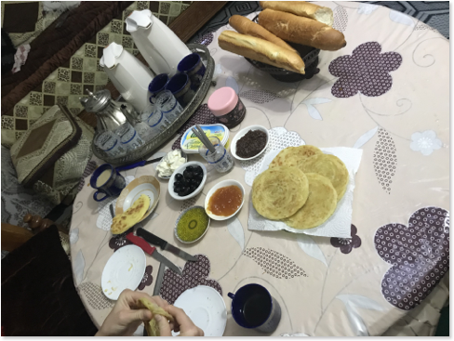

A photo of our breakfast at the host family.

This is a photo of our lunch at a very cute restaurant in Rabat. We got many times a three course lunch. It was really nice and I adore the Moroccan food, especially the Minced Meat, but in my opinion it was too much. I would never eat so much food at home, not even for dinner. I think it is really nice that we tried so many different kind of Moroccan food.

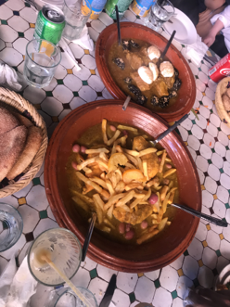 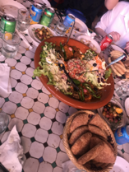

**Reflection**

**A** I have learned many things during this trip, things in general about Morocco, but also cultural things and things concerning business life in Morocco. I think the most important thing I have learned is how the business life in Morocco is and that people seem to be happy with what they (at least the most people I have spoken to and who I’ve met). It is a chaotic country, especially when you visit for example a market or get into a taxi, but the country is beautiful. Morocco has so many things to offer, the busy city’s, the country side, the mountains, the sea, the dessert I think it’s a beautiful country and it has so much more to offer than most people think. So all the things I have learned are useful for my future, but the thing I can apply the most during my study program will probably be my English which have been improved during my trip and also working within multicultural groups. I already had some experiences with working within multicultural groups but this ISA has me not only learned about the Moroccan culture, but also about the cultures from my travel mates. Learning about different cultures is very useful for the IB course and for in the future. I will apply my knowledge in future group projects.

**B** This ISA changed me in a way of that I know now how business is done in companies as for example in Morocco. We have been to a company (Seivita) where they make clothes for example ZARA. I knew that the circumstances of places where ZARA lets its clothes make are not always really well. At Seivita I saw a situation which I found really depressing. I found that the circumstances were really poor and the people did not looked happy. This changed me in a way that I know would think twice before I buy something at Zara. It also really let me think about what bad circumstances could have for your employees. I hope one day that these circumstances change, but probably in the near future it will not happen. The thing is, I have heard already so many times at the news how bad the circumstances are at those places, but now I have seen it with my own eyes it really changed my mind about it. And I know that it is at some places even worse.

**C** What did not went really well during this trip was my French. I have had some French during high school but beside that I have never spend any attention to this language. I know that a lot of people in Morocco did not speak English so I knew before hand that it would have been good if I learned some French words to make it easier for myself and so I could communicate with the people. Unfortunately I did not spend a lot of time to improve my French, so this is something I would do the next time different. What did went well, is that of course even you do not speak a language there is always a way to communicate with people and I think I did very well even my French was not really good. I think that was even more fun and challenging. I communicated with expressions and gestures and it worked out. During the trip I also learned some more French so it worked out really well the communication with the Moroccan people in the end.

**D** These were the goals I picked:

**Professional Practice Learning outcomes**

* **Ability to work in a multicultural team:** Understand diverse set of behaviours, attitudes, and practical skills **and** Ethical responsibility within the professional context

**Cultural immersion Learning outcomes**

* Ability to analyse and interpret behaviour of self and others
* Effective communication skills

I think I have reached the first goal but I could still work on it: working in a multicultural team and understand diverse set of behaviours, attitudes and practical skills. On the first day we had to do the assignments within a group. Our group consists of 5 Dutch students and one Italian students. That is why I think that I could still work on this goal. There is still a lot to learn about different cultures of different students. During the trip we have spend a lot of time together as a group so that also helped me to understand different behaviours, attitudes and practical skills. I would like for my next ISA to go somewhere where we work together with students from other universities so I can really experience how it is to work in a multicultural team. The work within our assignment team went really well I think.

The other goal I had set, *Ability to analyse and interpret behaviour of self and others,* I think I can say that I accomplished this goal. During our stay at the host family I analysed the behaviour of everyone and my own behaviour. For example once during breakfast when everyone was finished, but still sitting around the table I asked if it was okay if could go upside to shower because we had to leaver within 45 minutes. It was okay, but her response was different then when I asked it the day before, before we started breakfast. Next time I know that I will be better if I go for shower before breakfast or when everyone has left the table.

The other goal, effective communication skills, was a little bit hard since my French was not going really well, but overall, the communication between me and the Moroccan people went really well I think. I just used expressions, gestures and sometimes google translate, but I am satisfied. For the next time I will try to spend some more time on learning a language since it is easier to communicate.